# Exercise Set#3 - Management and Network administration basics, usage of advance commands

**Management and Administration basics**

The Objective is to learn all process, display, control, basic system and network administration commands.

**Videos :** Linux3-process_control_commands & Linux3-networking_commands

**1. Job/Process control commands**

**a. Show all running process <ps>**

**Ans :**   
 The ps command provides a snapshot of the current processes on your system. Without any options, `ps` displays information about the processes associated with the current terminal session.

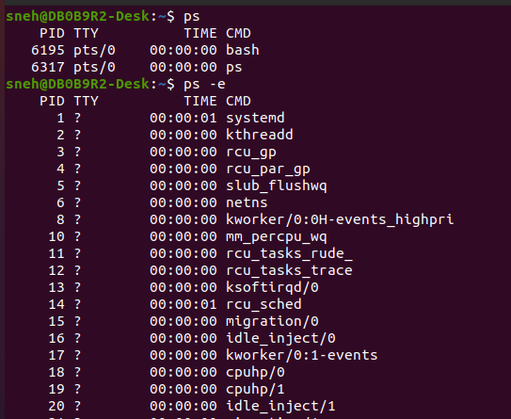

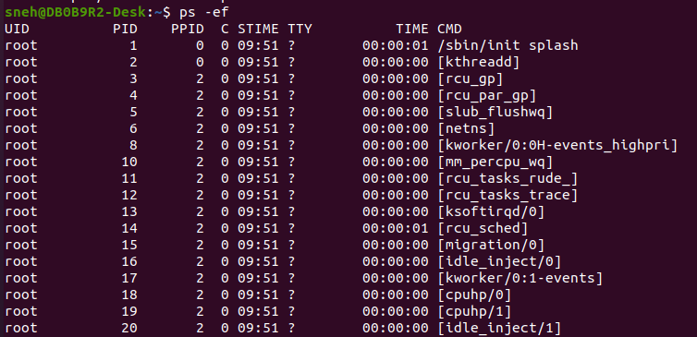

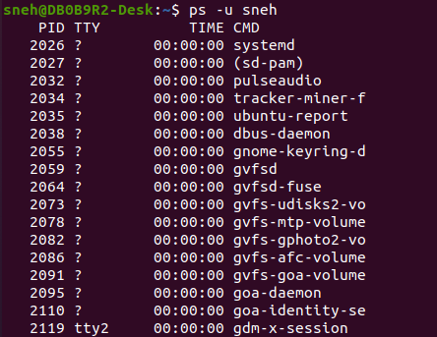

**b. Get the overview of the systems memory <free>**

**Ans :**

Free command displays free RAM and Swap memory available.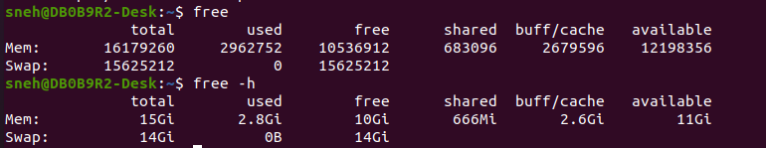

**c. Learn how to run a process in background**

**Ans :**

Using “&” at the end of the command:

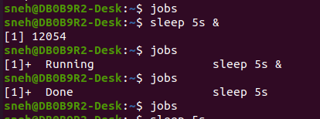

Using “bg” after starting a foreground process:

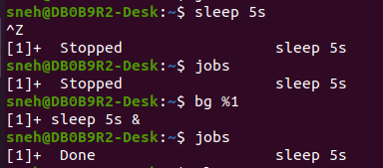

**d. List the background process <fg>**

**Ans :**

We can use jobs command to list the background processes.



We can use fg command to bring process to foreground

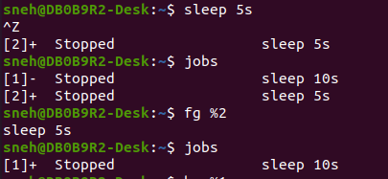

We can use disown command to disown the job :

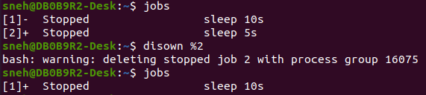

**e. Utilization of the processor <top>**

**Ans :**

Top (Table of processes) provides real time view of running processes and resource utilization.

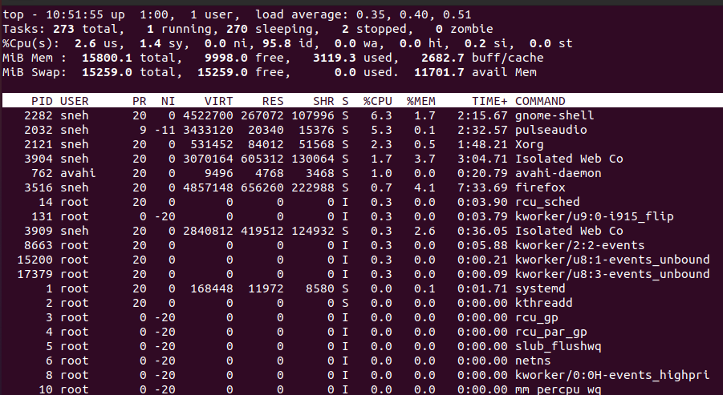

It is interactive as we can provide options :

q - quit

k - kill pid

n - no. of tasks displayed

d or s - change duration of refresh

u - filter by user

**f. Killing a particular process <kill>**

**Ans :**

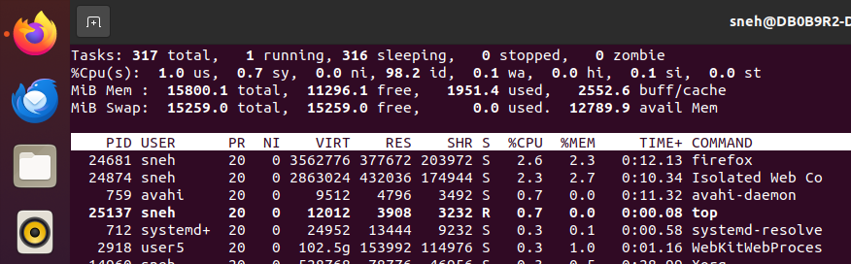





We have options(signals) in kill command :

-1 -> To restart the process

-15 -> Gracefully terminates

-9 -> Forcefully kills

We can directly kill process from top command by pressing k :

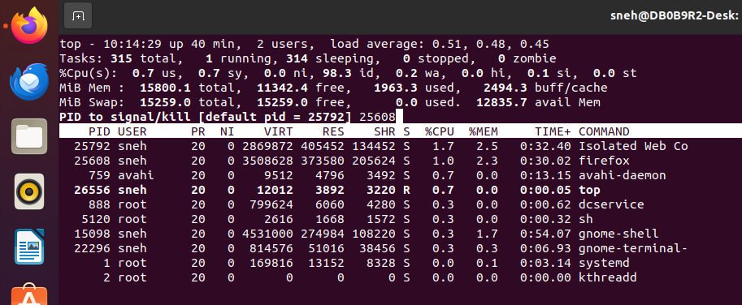

**2. User management controls**

**a. List users logged onto the system <who>**

**Ans :**

Who command Shows list of currently logged in users



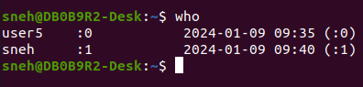

**b. Display more information about the user <finger>**

**Ans :**

Finger command is for showing detailed information about the user

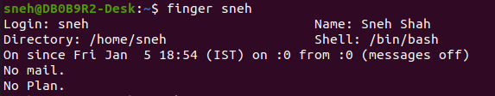

**c. Display what you are logged into as <whoami>**

**Ans :**

Whoami which is who am i is used to show name of current user



**d. Understand what a Super user is. Switch to Super User <su>**

**Ans :**

A superuser is a special user account that has administrative privileges and can perform tasks that regular users cannot. The superuser has unrestricted access to the system and can modify system files, install or remove software, and make changes to system configurations.

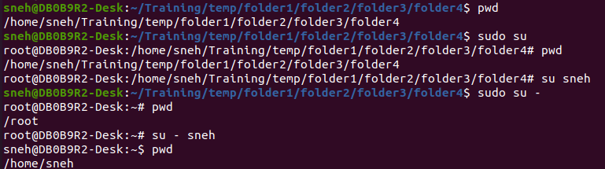

**e. Create a user, delete a user <useradd, userdel>**

useradd :

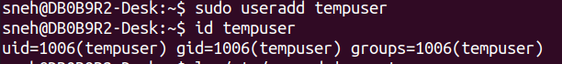

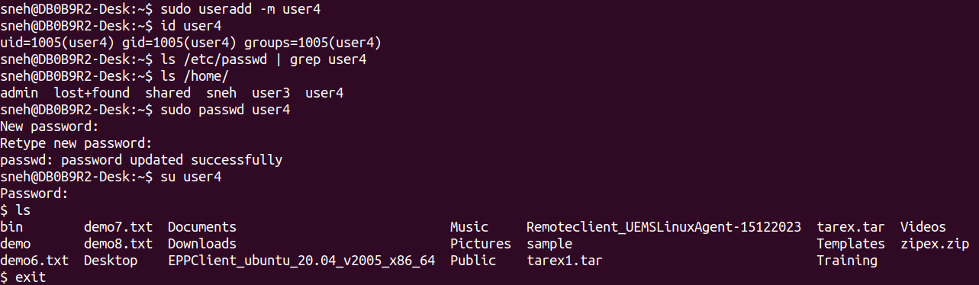

Userdel :

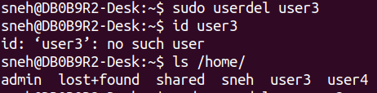

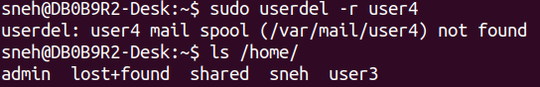

**3. System administration command**

**a. Change the owner and group of the directory and all its contents <chown>**

**Ans :**

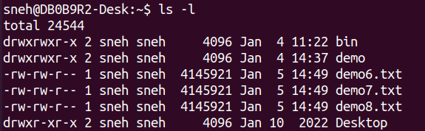

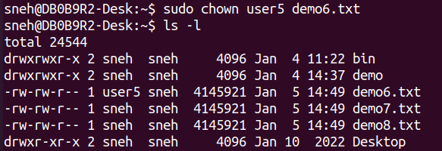

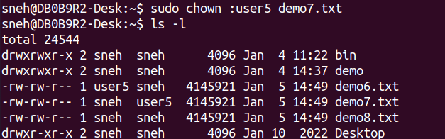

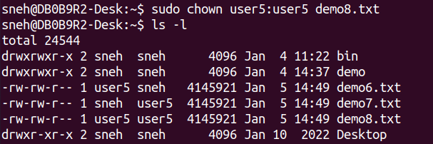

**b. Check the system kernel version <uname>**

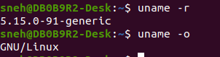

**c. Mount a formatted partition of windows onto Linux <mount>**

**Ans :**

Identify the Windows Partition:

Use the lsblk or fdisk -l command to list all available block devices and partitions. Identify the partition to mount.

Create a Mount Point:

sudo mkdir /mnt/windows

Mount the Partition:

sudo mount /dev/sdXn /mnt/windows

By using this command to set mount point it will be on temporary basis and disappear as soon as reeboot

To verify that the partition is successfully mounted:

ls /mnt/windows

To Make the Mount Permanent:

Add an entry to the /etc/fstab file:

**d. Unmount the partition <umount>**

**Ans :**

When done using the partition, it can be unmounted using the umount command:

sudo umount /mnt/windows

**e. Creating a particular filesystem <mkfs.>**

**Ans :**

The mkfs command is used to create a filesystem on a disk partition. There are several commonly used filesystems in the Linux like ext, xfs, btrfs, fat32, ntfs,etc.

To view filesystem of disk partitions we can use lsblk -f command:

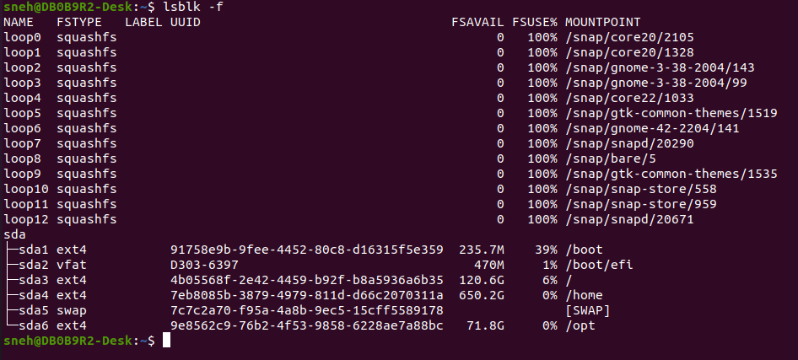

To create a filesystem of a particular type :

sudo mkfs.ext4 /dev/sdX1

This will make the partition with ext4 filesystem. For other filesystem replace ext4 with required filesystem.

**f. Shutting down the system <shutdown> (Caution: This command will shut down your system thus use with care).**

**Ans :**

The shutdown command in Linux is used to shutdown the system in a safe way. You can shutdown the machine immediately, or schedule a shutdown using 24 hour format.







**g. Change password of a user<passwd>**

**Ans :**

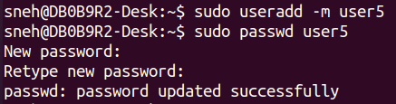

**h. File system check with <fsck>**

**Ans :**

fsck is used to check one or more Linux file systems.

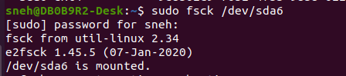

**i. Displaying and changing partition using <fdisk> (Caution: If used without care, it can corrupt existing partition and you may not able to boot next time)**

**Ans :**

The fdisk command is used for disk partitioning.

To display information about the existing partitions on a disk :

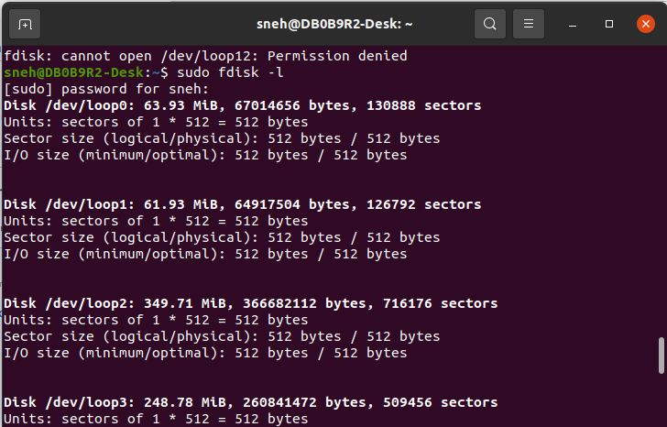

We can also use lsblk command to view disk partition:

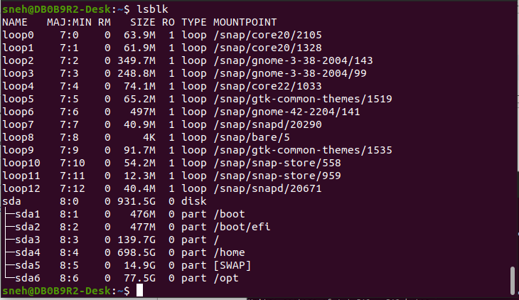

**4. apt-get installation**

**a. How does apt-get works?**

**Ans :**

apt-get is a command-line package management tool . It is part of the Advanced Package Tool (APT) system, which automates the process of installing, updating, upgrading, and removing software packages on a Linux system.

* Updating Package Information:

**sudo apt-get update** - update the package lists

* Installing Packages:

**sudo apt-get install package_name** - downloads and installs the specified package

* Upgrading Packages:

**sudo apt-get upgrade** - upgrade installed packages to their latest versions

* Upgrading the Distribution:

**sudo apt-get dist-upgrade** - upgrade the entire system

* Removing Packages:

**sudo apt-get remove package_name** - remove a package without affecting its configuration files

**sudo apt-get purge package_name** - remove the package along with its configuration files

**b. What steps are followed when we install/remove any package from system**

**Ans :**

**Installing a Package:**

Package Availability Check

Dependency Resolution

Package Download

Package Extraction

Configuration

Post-Installation Scripts

**Removing a Package :**

Dependency Check

Unused Dependency Removal

Package Removal

Post-Removal Scripts

**c. Install iperf application in your system (If iperf is already installed removed it and then install) <apt-get>**

**Ans :**

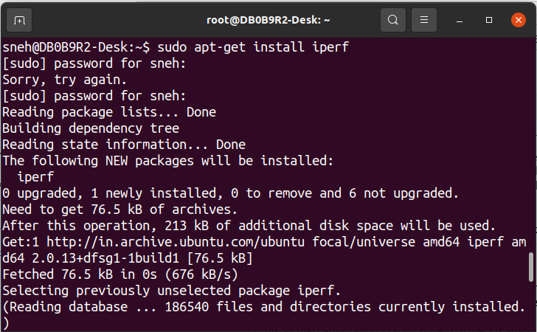

**d. Check if ncurses library is installed in your system, if not installed the appropriate ncurses package for your system. <aptitude>**

**Ans :**

To check if the ncurses library is installed : 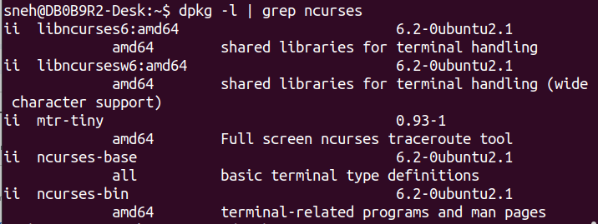

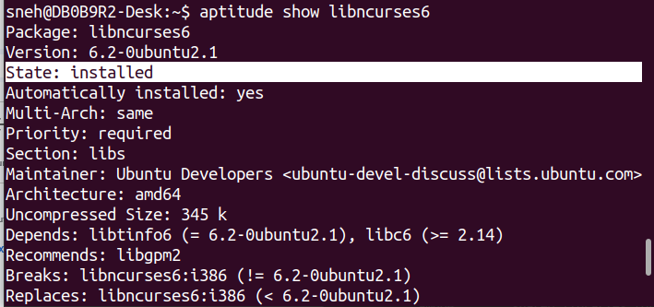

e. Uninstall iperf application previously installed <apt-get>

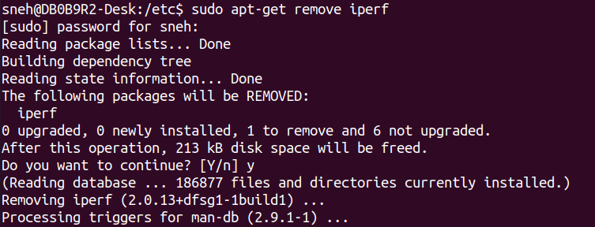

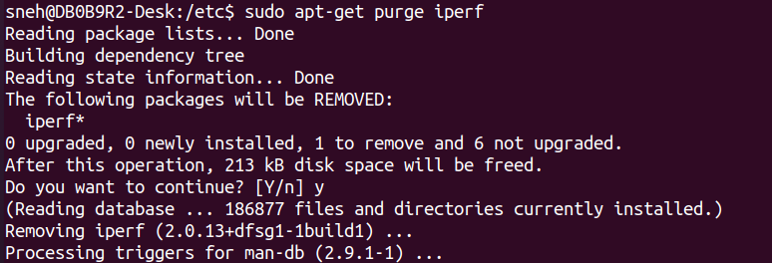

**5. Network administration command**

**a. Displaying and configuring the network interface <ifconfig>**

**Ans :**

ifconfig (interface configuration) command is used to configure and display network interfaces

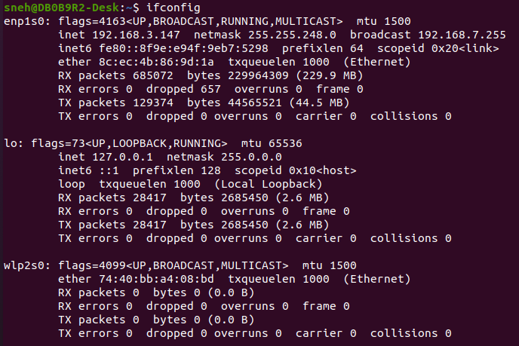

We can configure interface as follows :

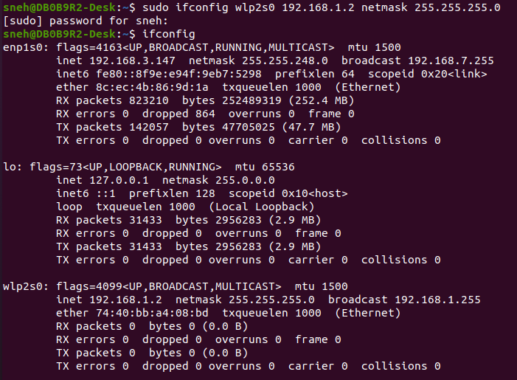

But this changes will be temporary and will be lost after reboot.

**b. Test networking with another machine <ping>**

**Ans :**

The ping command is commonly used to test network connectivity between two machines.

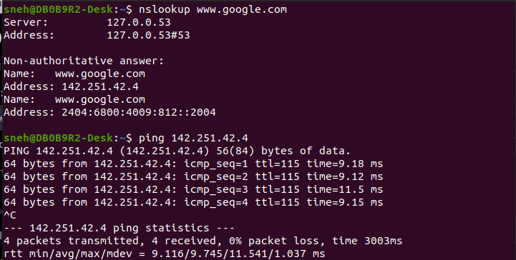

**c. Defining a default gateway <route>**

**Ans :**

The route command displays and manipulate IP routing table for your system.

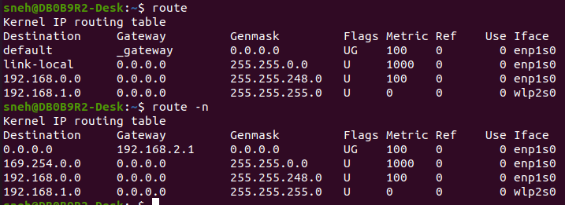

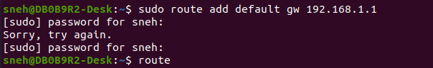

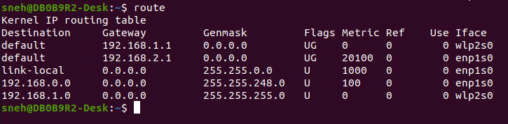

This will set temporary default gateway for system and will be lost after a reboot.

To make it permanent we can add entry in /etc/network/interfaces.

**d. Checking the host name of your system <hostname>**

**Ans :**

Linux hostname command allows us to set and view the hostname of the system.





This will set temporary hostname for system and will be lost after a reboot.

To make the hostname change persistent across reboots, update the /etc/hostname file with the new hostname.

**e. Checking the status of the port <netstat>**

**Ans :**

Netstat is an abbreviation of network statistics which provides network related information.

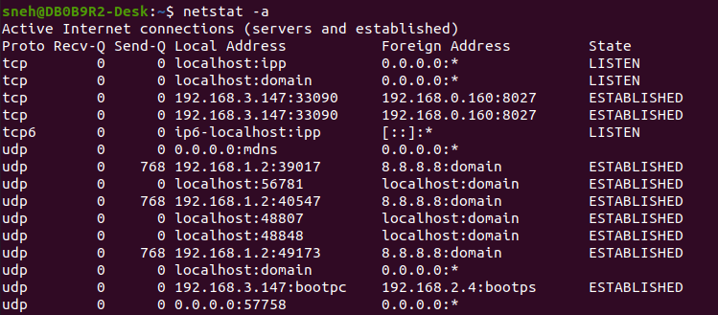

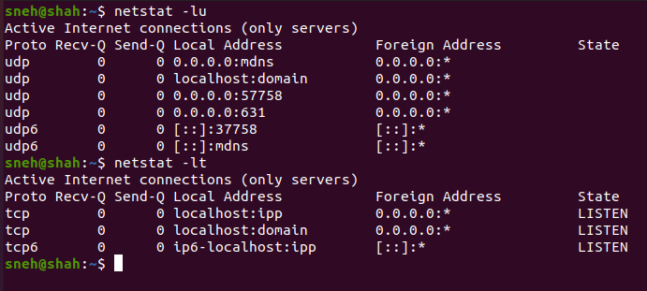



**f. Capturing a interpreting a network packet <tcpdump>**

**Ans :**

tcpdump is a powerful command-line packet analyzer that allows you to capture and interpret network packets

It provides detailed information about the packets flowing through a network interface

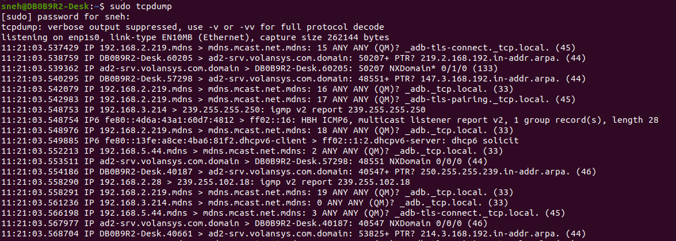

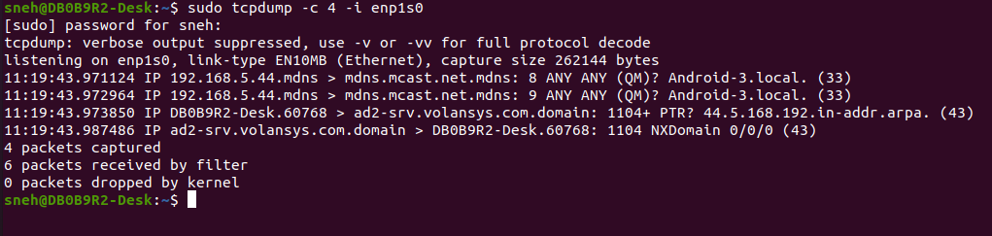

**g. List series of host through the packet is routed <traceroute> OR <tracepath>**

**Ans :**

Linux traceroute command is a network troubleshooting utility that helps us determine the number of hops and packets traveling path required to reach a destination.

It send 3 packets to the hop and record time.

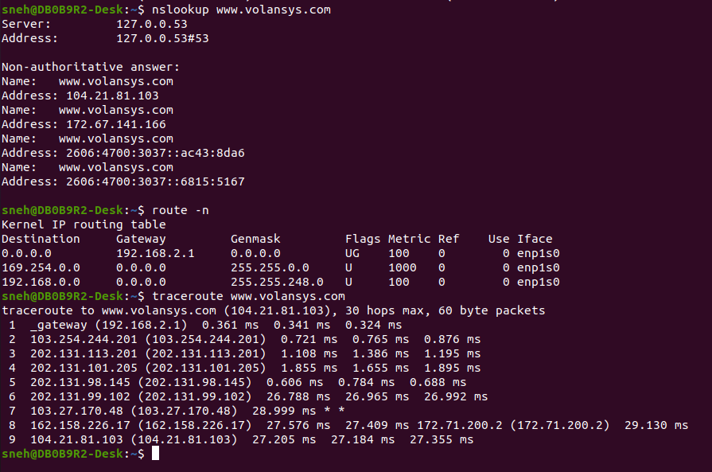

**h. List info about machines that respond to SMB name queries on a subnet <findsmb>**

**Ans :**

“findsmb” command is used to display or list information about machines that respond to SMB name queries.

SMB - Server Message Block

**i. Bringing the network interface UP or DOWN using <ifconfig>**

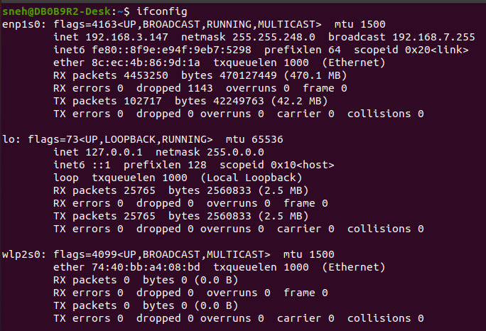

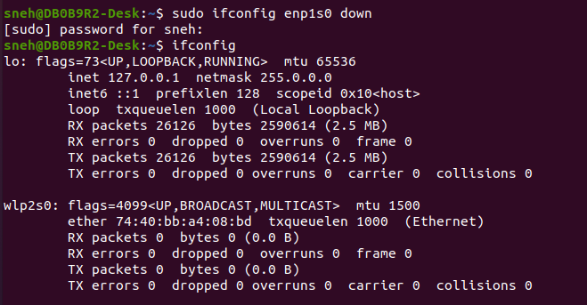

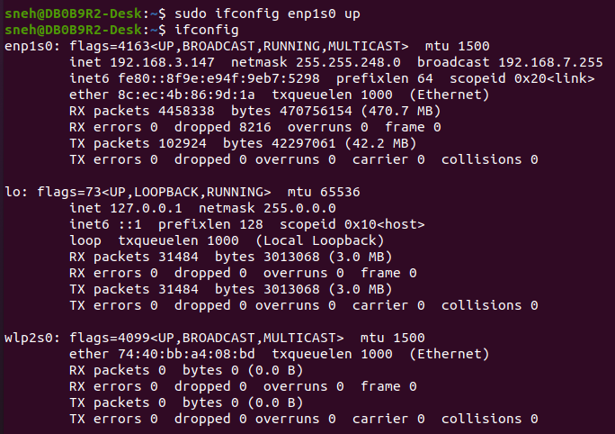

These commands are useful when you need to manually enable or disable a network interface

**j. How to configure network interface for DHCP or have static IP address?**

**Ans :**

**For Static ip :**



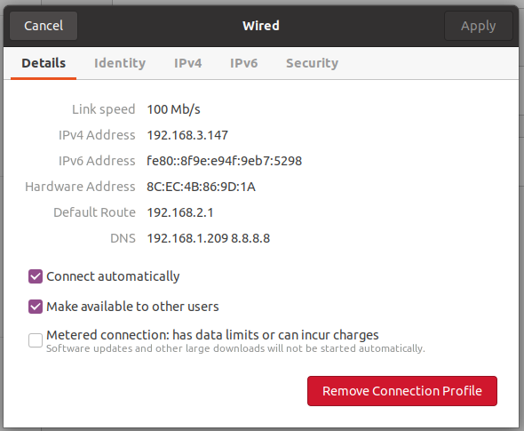

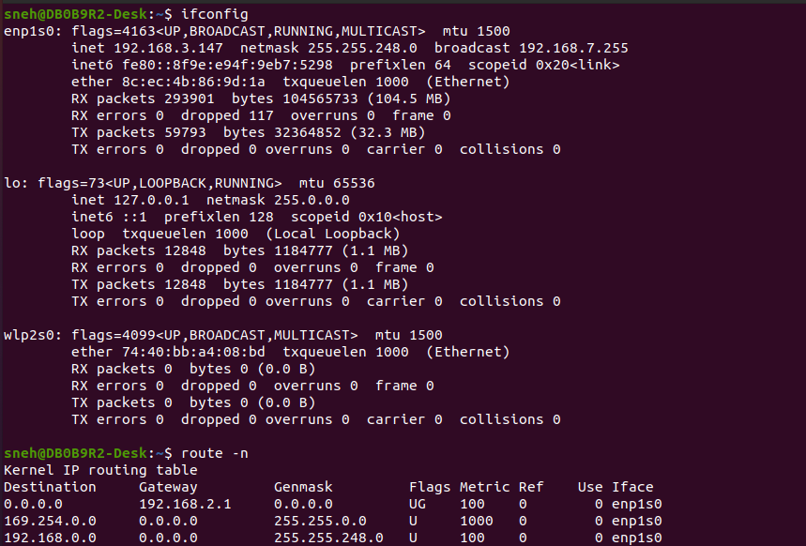

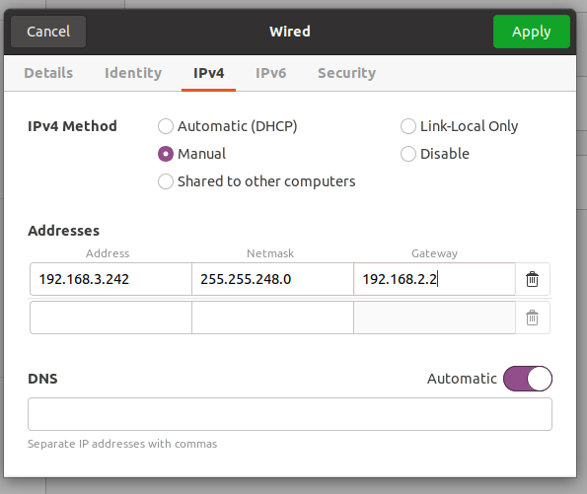

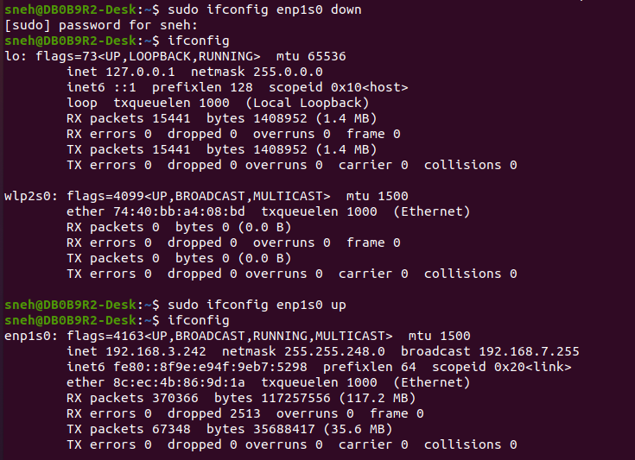

We can also achieve same by editing address in /etc/netplan/01-netcfg.yaml

**For DHCP :**

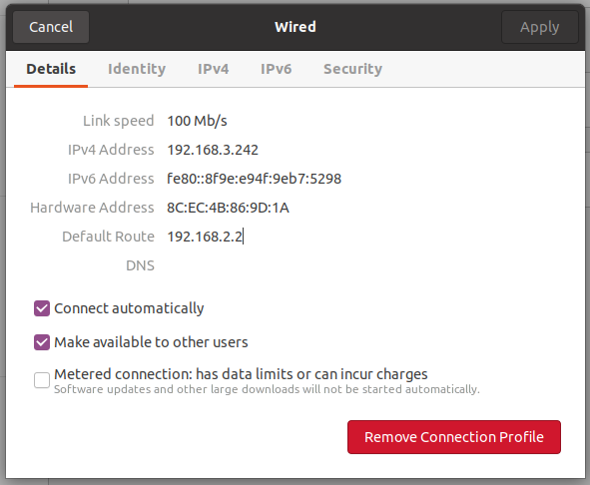

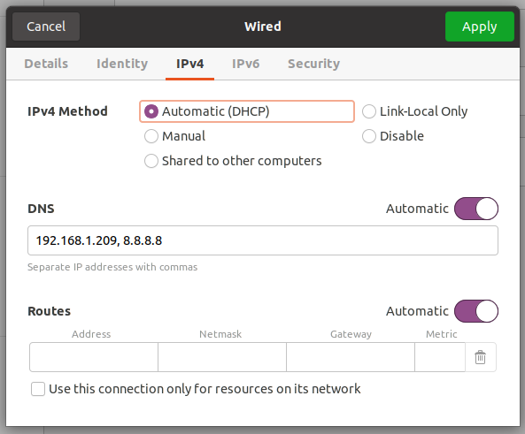

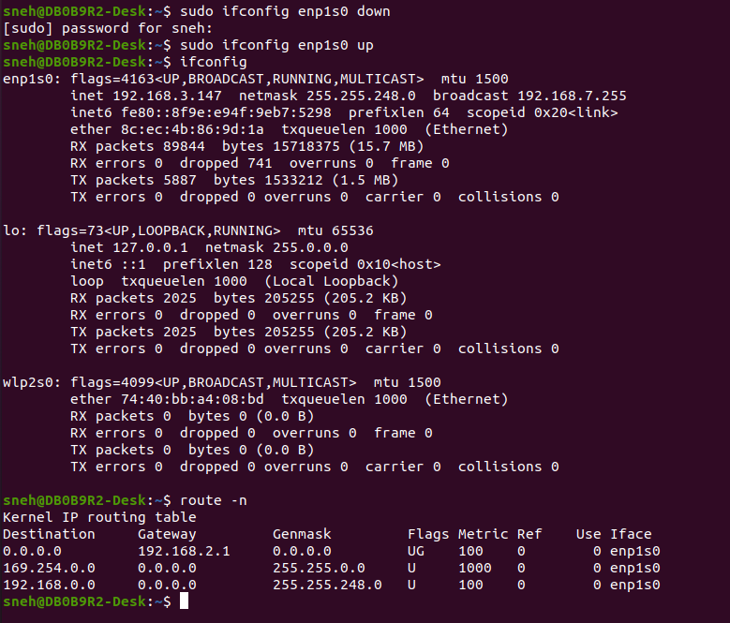

**k. How to specify gateway, dns for accessing other networks?**

**DNS:**

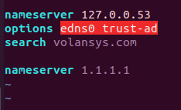



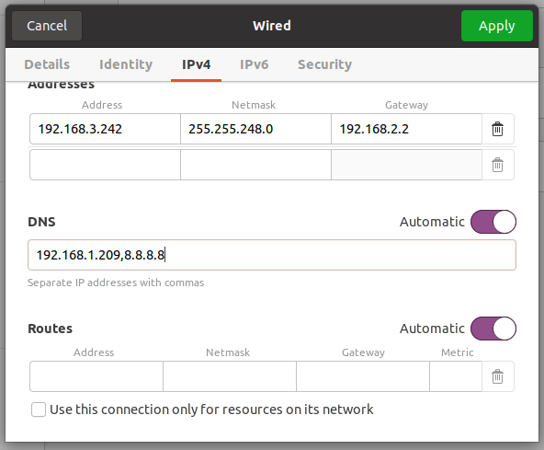

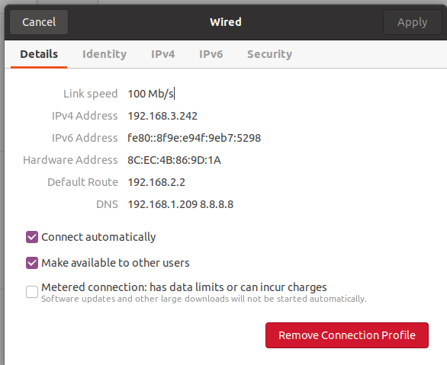

We cann also achieve same by editing nameserver in /etc/resolv.conf file.

**Gateway :**











